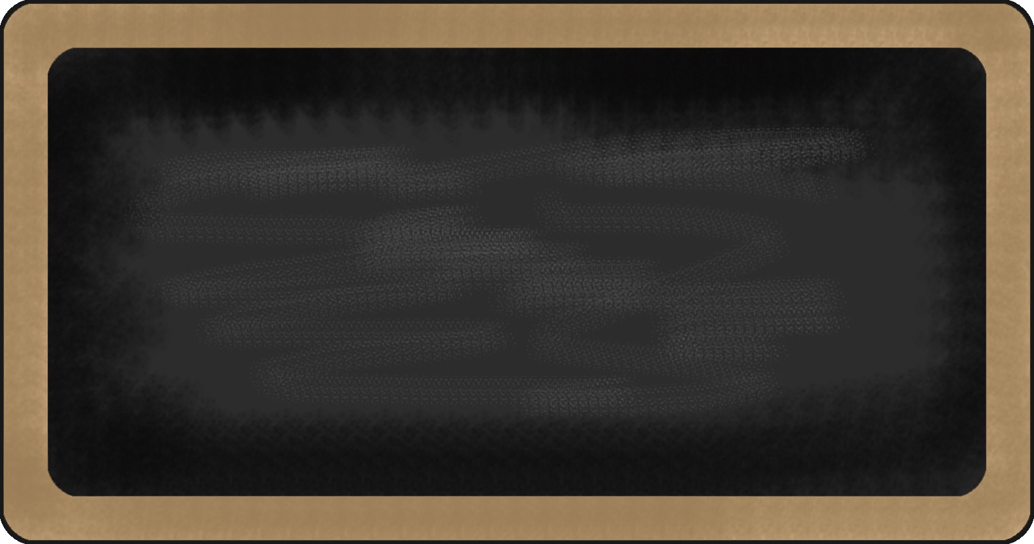

Kindergarten News

Sight Words
a, like

Upcoming events

October 26th – Halloween Howl (6:00 -7:30 pm)

November 5th – Picture Retake Day





Notes from the teacher:

The cooler weather is here. Please ensure that your child is dressed for the season.
Our breakfast program is going well! Enjoy it when you arrive (if you’re hungry).
The breakfast program closes at 8:00 am.
If you have any questions or concerns please feel free to contact me at crystal.bragdon@nbed.nb.ca, or call the school.
Our Halloween Celebration will be on Wednesday, October 31st. Please wear orange and black. We will be having a special snack. If you would like to contribute please email me. I am looking for 1. Small fruit tray, 2. Small veggie tray, 3. Cheese and crackers, 4. A treat, 5. 18 juice boxes.




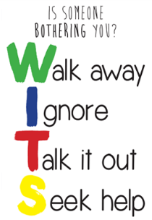


What we are learning this week:

Reading | Writing | 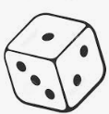  Math | You and Your World
- New Letters: m, d  - Sight Words: like, a  - Strategy: Eagle Eye – Look at the picture. Think “What is in the picture that starts with the beginning letter?”  - Review letters: s, a, t, i, p, n, c/k, e, h and r  - Review sight words: is, to, I, me,the | - Practice writing proper letter formations for: h, r, p, n, t, i, s, a, c/k, e  - Practice reading, writing and spelling sight words: the, is, me, I, to  - Practice writing their names | - Subitizing ( Recognize a familiar arrangements of objects at a glance)  - Relate a numeral to its quantity 0 to 5  - Say the number sequence 0 to 5  - Identify, create and reproduce patterns | - W.I.T.S. Strategy (Walk Away, Ignore, Talk it out, Seek help)  - Habit 1: Be proactive.

